Livetransparent.com
Executive Report Framework
A guide for the automation team on how to structure the reporting dashboard — what to measure, where to get the data, and how to diagnose conversion gaps.
Tools: GoHighLevel | Google Analytics | Google Search Console
Platforms: Meta Ads | Google Ads | Facebook/Instagram/LinkedIn (organic) | Website | Email | LinkedIn DM | SMS

The core principle
Cameron wants GoHighLevel to be the single source of truth for the executive report. GA4 and Search Console feed the Traffic layer, but the moment a visitor becomes a lead, GHL owns the story. The automation team's job is to stitch these three sources into one unified dashboard view.

Every report answers three questions in this order:

1. Traffic  Are our efforts attracting visitors? | 2. Leads  Is traffic converting to leads? | 3. Sales  Are leads converting to sales?

Layer 1: Traffic
Primary source: Google Analytics (GA4) + Google Search Console
GoHighLevel does not report on website traffic. All traffic volume and channel attribution must come from GA4 and GSC, then be joined to GHL lead data by date range and UTM source.

Top-line metrics to display
Metric | Description | Source
Total sessions | All website visits across all channels combined | GA4
Sessions by channel | Organic, paid, direct, social, email, referral breakdown | GA4
Organic impressions | Search visibility, total clicks, and average position | GSC
Organic top queries | Which search terms are driving visitors | GSC
Paid ad clicks | Meta + Google Ads clicks landing on the site | GA4 / Ads

Granular drill-down signals
• Landing page exit rates — which pages are losing visitors immediately
• Bounce rate by channel — is paid traffic lower quality than organic?
• Time on site by source — are visitors engaging or bouncing
• UTM tag coverage — are social posts and email campaigns properly tagged?
• New vs returning visitors — are we reaching new audiences or recycling existing ones

Layer 2: Leads
Primary source: GoHighLevel (master record) + GA4 (form event validation)
GHL is the system of record for all leads. Every new contact added to the GHL pipeline counts as a lead. GA4 supplements by tracking form interactions so the team can see form visits vs. actual submissions.

Top-line metrics to display
Metric | Description | Source
New leads (total) | All new contacts added to GHL pipeline in the period | GHL
Leads by source | Which channel/form/campaign captured each lead | GHL
Email lead response | Replies and link clicks from nurture sequences | GHL
Form submissions | Website form fills, landing page captures | GHL + GA4
SMS / DM responses | Replies to LinkedIn DM and SMS outreach campaigns | GHL
Cost per lead | Ad spend divided by leads from that channel | GHL + Ads

Granular drill-down signals
• Contact page visits vs. form submissions (gap = form abandonment) — GA4 + GHL
• Form field drop-off — which field causes people to leave the form
• Lead quality score — are GHL leads from paid ads actually converting downstream
• Response time to new leads — how fast does the team follow up after capture
• LinkedIn DM reply rate — outreach volume vs. replies received
• SMS opt-in rate — how many contacts are reachable via SMS

Layer 3: Sales
Primary source: GoHighLevel only
Sales data lives entirely in GHL. A sale is recorded when a lead moves to a Won stage in the GHL pipeline. No other tool needs to be queried for the Sales layer.

Top-line metrics to display
Metric | Description | Source
Deals closed | Leads moved to Won status in GHL pipeline | GHL
Revenue | Total value of all closed deals in the period | GHL
Close rate | Percentage of leads that converted to sales | GHL
Sales by lead source | Which originating channel produces the most closed deals | GHL
Sales cycle length | Average days from first contact to deal close | GHL

Granular drill-down signals
• Pipeline stage drop-off — at which stage do most leads stall or go cold
• Lost reason tags — what reason is recorded when a lead is marked lost
• Follow-up attempts before close — how many touchpoints before a deal closes
• Best closing channel — which lead source has the highest close rate (not just volume)
• Revenue by lead source — not just count but actual value per channel

Tool coverage summary
A quick reference for what each tool can and cannot provide:

Tool | Traffic | Leads | Sales
Google Analytics | Yes (primary) | Partial — form events only | No
Search Console | Yes — organic only | No | No
GoHighLevel | No | Yes (primary) | Yes (primary)

Important: the Traffic → Lead bridge requires both GA4 and GHL. GA4 tracks who visited the form page; GHL tracks who submitted it. The gap between those two numbers is the form abandonment rate.

Conversion gap analysis
When the numbers at one layer are disproportionately lower than the layer above, these are the questions to investigate and where to look:

Gap | Question to answer | Where to look
Traffic → Lead gap | Why is traffic not converting to leads? | GA4 behaviour flow + GHL form capture rate
Lead → Sales gap | Why are leads not converting to sales? | GHL pipeline stages + lost reason tags
Channel ROI view | Which channels are worth the investment? | GA4 traffic + GHL lead source + GHL deal source cross-referenced with ad spend

Integration notes for the automation team
Three tasks are needed to make this dashboard work:

- Pull GA4 sessions + channel breakdown via the GA4 Data API, filtered by date range.
- Pull GHL pipeline data — new leads, lead source tag, pipeline stage, won deals, revenue — via the GHL API.
- Stitch by date range and UTM source so all three layers render in one unified dashboard view.

Critical dependency: UTM tags must be consistently applied to all Meta Ads, Google Ads, email campaigns, and social posts so GHL can correctly attribute each lead to its originating channel.

Dashboard mockup
The wireframe below shows how the GHL executive dashboard should look when fully built — including the sidebar navigation, the core question health indicators, the Traffic → Leads → Sales funnel, KPI cards with their data source labels, channel breakdown bars, pipeline drop-off view, and the granular gap analysis panels.

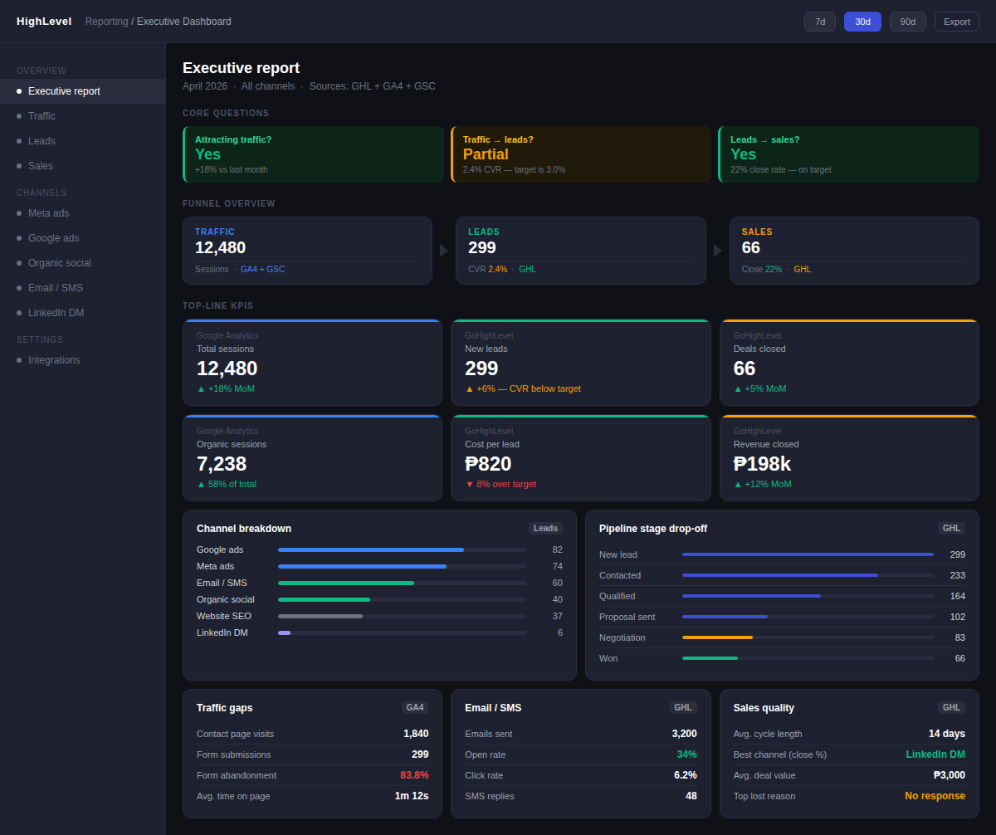
Fig. 1 — GHL executive dashboard mockup. Data source labels (GA4, GSC, GHL) appear on each widget so the team always knows where the number comes from.

Prepared for Livetransparent.com — Version 1.1

